Multi-Modal Data Fusion With Federated Multi-Head Attention for Diabetic Retinopathy Severity Classification
Ezembu John^{1*}, Rita Orji² and Oladapo Oyebode³
^{1*}Faculty of Computer Science, Bowen University, Iwo, Osun, Nigeria
0009-0001-3460-7041.
²Faculty of Computer Science, Dalhousie University, Halifax, Canada
0000-0001-6152-8034.
³Faculty of Computer Science, Dalhousie University, Halifax, Canada
0000-0002-5797-7790.
*Corresponding author. E-mail(s): ezembu.john@bowen.edu.ng; Contributing authors: rita.orji@dal.ca; oladapo.oyebode@dal.ca.

Abstract
Purpose: Diabetic retinopathy (DR) is a leading cause of vision loss. Deep learning models have achieved high accuracy in DR detection from fundus images, but often ignore valuable patient information in electronic health records (EHR). This study develops a multi-modal data fusion approach for DR severity classification, integrating fundus images with key EHR features (glycated hemoglobin HbA1c, diabetes duration, and age) to improve performance. We also extend it to a federated learning framework for decentralized training across sites while preserving privacy. Key research questions: Can attention-based fusion of imaging and EHR data enhance DR classification over single-modality models? Does federated learning achieve comparable results to centralized training without sharing sensitive data?
Methods: The architecture utilizes ResNet-18 for extracting features from fundus images and a multilayer perceptron (MLP) for processing EHR tabular data. A multi-head attention mechanism fuses modalities to learn task-relevant interactions. Federated learning is implemented via FedML, simulating training across four client sites. Experiments use the RetinaMNIST dataset (1,600 fundus images) augmented with synthetic EHR data.
Results: The multi-modal model outperformed image-only and EHR-only baselines, achieving higher accuracy and area under the ROC curve (AUROC). The federated learning variant yielded performance close to the centrally trained model, with only a minor decrease in AUROC. Visualizations of attention weights revealed clinically relevant retinal regions.
Conclusion: Incorporating EHR data via attention-based fusion significantly improves DR severity grading, while federated learning facilitates secure multi-center collaboration without data sharing. This approach holds promise for real-world clinical deployment in privacy-sensitive environments.
Keywords: Diabetic retinopathy, multimodal data fusion, attention mechanism, federated learning, electronic health records, medical imaging

Introduction
Diabetic retinopathy (DR) is a leading cause of blindness in working-age adults [2]. The global diabetic population is projected to reach 700 million by 2045 [1], emphasizing its growing public health impact. Accurate grading, from no retinopathy to proliferative DR, is essential to prevent vision loss. Deep learning (DL) has advanced automated DR screening using retinal fundus images. However, ophthalmologists also consider systemic factors, such as glycated hemoglobin and disease duration, when evaluating risk. Most DL models rely only on images, overlooking electronic health record (EHR) data. Combining both modalities has improved predictions, with one study reporting a 97.96% AUC [4].
Designing effective fusion mechanisms is challenging. Early fusion, based on simple feature concatenation, is common but often fails to capture cross-modal interactions [21]. Advanced strategies, including attention-based and gated fusion, adaptively weight modality contributions.
Attention mechanisms, in particular, help models focus on relevant image regions or patient-specific clinical features [21].
Medical data are often siloed across hospitals due to strict privacy regulations, hindering centralized multi-institution training [10]. Federated learning (FL) enables collaborative model training without sharing raw data [10]. Each client (e.g., hospital) trains locally and sends model updates for aggregation, typically via the Federated Averaging (FedAvg) algorithm. FL preserves privacy while leveraging multi-center data, with one study reporting a dice score of 0.852 for FL-based brain tumor segmentation, close to 0.862 from centralized training [11].
In this work, we propose a multi-modal architecture for diabetic retinopathy (DR) severity grading that integrates fundus images and electronic health record (EHR) features within a federated learning (FL) framework for privacy-preserving, distributed training. Our contributions are as follows:
We developed an end-to-end network combining a ResNet-18 CNN for image analysis and a multilayer perceptron (MLP) for three EHR inputs (HbA1c, diabetes duration, age). A multi-head attention module enhances image features based on EHR context, replacing simple concatenation. We simulated FL with the FedML library across four client nodes representing distinct clinical sites. Attention maps illustrate how EHR data guides the model’s focus on retinal pathology (e.g., microaneurysms in high-HbA1c patients). We also report an ablation study comparing our fusion module to baseline strategies and discuss implications for real-world deployment. The paper is structured as follows: Section 2 reviews related work, Section 3 describes the methodology, Section 4 presents results, Section 5 discusses findings and limitations, and Section 6 concludes.

Related Work

Multi-Modal learning with Images and EHR
Combining imaging with clinical data improves diagnostic and prognostic models [4]. A review [5] reported that multimodal deep learning, integrating medical images and EHR data, often outperforms single-modality models. Fusion approaches include early fusion (feature concatenation), late fusion (merging outputs via averaging or voting), and intermediate fusion (one modality guiding feature extraction) [21]. In DR, few datasets combine fundus images with EHR. One study [4] merged HbA1c, blood pressure, and cholesterol with fundus images, achieving 96.84% sensitivity and 89.44% specificity, surpassing image-only models. TieNet [6] fused text and images via attention for chest X-ray diagnosis, while GMU [8] enabled adaptive fusion, improving multimodal results [21].
The Gap in the Integration of Fundus Imaging and EHR: Several studies have explored combining fundus images and EHR data for DR classification. [24] developed a neural network that processed both data types (age, gender, smoking status, lab tests), achieving a 97.96% AUC and surpassing single-modality models. Similarly, [25] proposed an early fusion LSTM model integrating fundus images, OCT, and EHR data, showing high accuracy. Our framework addresses this gap by using federated learning with multi-head attention to fuse imaging and non-imaging data effectively while preserving patient privacy across decentralized sources.
Attention-based Fusion: Attention networks have advanced natural language processing and computer vision, prompting interest in multimodal fusion. In medical imaging, spatial (key regions) and channel attention (feature maps) improve classification and segmentation [22], but self-attention is usually applied within a single modality. Cross-modal attention, where one modality guides another, remains underexplored. Here, we use a multi-head attention mechanism based on transformer architecture [21] to fuse image and EHR features, enabling the model to focus on image regions relevant to patient data, such as HbA1c levels, while capturing diverse cross-modal interactions [21].

Federated Learning in Healthcare
The template is used to format your paper and style the text. All margins, column widths, line spaces, and text fonts are prescribed; please do not alter them. You may note peculiarities. For example, the head margin in this template measures proportionately more than is customary. This measurement and others are deliberate, using specifications that anticipate your paper as one part of the entire proceedings, and not as an independent document. Please do not revise any of the current designations

Method

Dataset and Synthetic EHR Features
RetinaMNIST Imaging Data: We base our experiments on the RetinaMNIST dataset [23], a public collection of 1,600 fundus photographs derived from the DeepDRiD challenge with a benchmark AUC of 0.710. Each image is labeled with a DR severity grade of 0-4. The images were originally high resolution (around 1736×1824 pixels) but are provided in RetinaMNIST as 28×28 thumbnails for lightweight benchmarking. In our work, we obtained the RetinaMNIST images at higher resolution (we use 224×224 pixels) to fully leverage a deep CNN. We split the dataset into training, validation, and testing sets following the MedMNIST protocol: 1,260 images for training, 140 for validation, and 200 for testing (ensuring a roughly 9:1 split for train:val and using the original challenge validation set as our test set). The class distribution in the dataset is imbalanced, reflecting DR prevalence. For example, class 0 (no DR) constitutes about 40% of the images, while class 4 (proliferative DR) is only about 10%. During training, we addressed this imbalance by applying class-weighted loss and data augmentation on the minority classes (rotations, flips, and mild color jitter applied to images of mild-to-severe DR) to mitigate bias towards the majority class. Notably, the dataset does not provide patient identifiers linking images; thus, we treat each image as an independent sample (i.e., most patients contribute a single image). As disease severity increases, pathologies such as microaneurysms, hemorrhages, and exudates become more apparent. This figure illustrates the visual differences between classes.
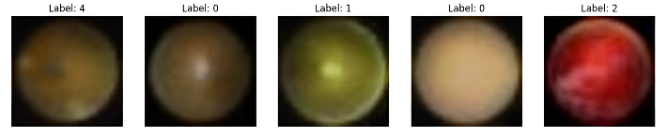
- Representative retinal fundus images for each DR severity class
TABLE 1
 | Dataset Composition
Dataset Partition | Number of Images | Percentage (%) | Usage
Training | 1,260 | 78.75% | Model training
Validation | 140 | 8.75% | Hyperparameter tuning and model selection
Testing | 200 | 12.5% | Performance evaluation

Synthetic EHR Data Generation: Alongside images, our model uses three patient attributes: HbA1c (glycated hemoglobin) level, diabetes duration, and age. Because the RetinaMNIST images are de-identified and lack patient metadata, we synthetically generated plausible EHR features for each image. [26] discusses using synthetic health data generated through federated learning to address privacy concerns linked to sharing real patient data. Their work shows that synthetic data can preserve the statistical properties of real datasets while reducing privacy risks. We drew on epidemiological insights to assign these features in line with DR severity, reflecting a realistic scenario where patients with worse DR often have longer diabetes duration and poorer glycemic control. Specifically, for each image labeled with a class (0=no DR, 1=mild DR, 2=moderate DR, 3=severe DR, 4=proliferative DR), we sampled:
HbA1c (%): from a normal distribution with a mean of 6.0 for class 0, increasing to 10.0 for class 4 (SD=0.5). Thus, a no-DR patient might have HbA1c of 5.5-7%, while a proliferative DR patient might have 9-11%, aligning with known links between high HbA1c and DR progression.
Diabetes Duration (years): from a distribution with a mean of 2 years for class 0, up to 20 years for class 4 (±2 years), reflecting that longer diabetes duration correlates with advanced DR. We capped duration at 30 years.
Age (years): Age was sampled uniformly from 30–80 years, independent of class, as it is a weaker DR severity predictor. We enforced age ≥ diabetes duration (e.g., 5-year history required age >5 years). The synthetic cohort's mean age was 50 years.
TABLE 2
 | Summary of Synthetic EHR Features
Feature | Description | Generation Method | Rationale | Inter-class  Difference  (p-value)
HbA1c (%) | Glycated hemoglobin level | Normal distribution, mean increases from 6% (class 0) to 10% (class 4), SD=0.5 | Reflects glycemic control with DR severity | < 0.001  (significant)
Diabetes Duration (years) | Duration since diabetes diagnosis | Increasing from a mean of 2 years (class 0) to 20 years (class 4), SD=2, capped at 30 | Longer duration correlates with advanced DR | < 0.001  (significant)
Age (years) | Patient's age | Uniform distribution between 30-80 years | Age is less directly predictive of DR but is included as a relevant demographic factor | 0.97  (n.s.)

These synthetic features were generated anew for each training epoch (with a fixed random seed per sample for reproducibility) so the model would not overfit to specific values but rather learn general associations. All features were normalized: age and duration were scaled to the 0-1 range (dividing by 100 and 30, respectively), and HbA1c was scaled by 0.1 (so 10% becomes 1.0). We acknowledge that these are simulated data for proof-of-concept. In real deployment, such features would be extracted from patient EHRs, and an ethical review or informed consent might be required. In our case, as we use publicly available de-identified data with synthetic additions, no institutional review board (IRB) approval was necessary because no real personal health information was used.

Multi-Modal Architecture
Our architecture (Fig. 2) comprises two modality-specific subnetworks and a fusion module. The image branch uses a ResNet-18 CNN pretrained on ImageNet. We removed the 1000-class fully connected layer, retaining the convolutional feature extractor to produce a 512-dimensional global feature vector via global average pooling.
The EHR branch is a two-layer MLP that processes three normalized inputs (HbA1c, duration, age). It uses 16 hidden units with ReLU activations and produces a 16-dimensional embedding representing patient risk factors in compact form.
The core of our model is the multi-head attention fusion module that merges the 512-dimensional (512-D) image feature with the 16-dimensional (16-D) EHR feature. Inspired by the Transformer-style attention mechanism [1], we adapt it for simplified cross-modal fusion. Specifically, we replicate the EHR feature into H attention heads (we use H=4 in our implementation) and linearly project each head to form a query vector $q_{h}∈ R^{d}$ (with $d=128$ chosen for the query/key dimension). The image feature vector is similarly projected to a key $k$ and value $v$ of dimension $d$ . In the formula, for head $h$:
${ q}_{h}= W_{q}^{h}f_{EHR}, k_{h}= W_{k}^{h}f_{img}, v_{h}= W_{v}^{h}f_{img}$ (1)

Where $f_{EHR}∈ R^{16}$ and $f_{img}∈ R^{512}$ are the modality features, and $W_{q}^{h}, W_{k}^{h}, W_{v}^{h}$ are learned projection matrices. We then compute an attention weight $α_{h}= softmax\left(\frac{\left(q_{h}^{T}k_{h}\right)}{sqrt\left(d\right)}\right)$ (for simplicity, here $α_{h}$ is a scalar and $q_{h}^{T}$ denotes the transpose of the query vector $q_{h}$​. Transposition is required for the dot product with the key vector $k_{h}$​ since both $q_{h}$ and $k_{h}$ represent the entire modality features and $sqrt\left(d\right)$is a normalization factor, where $d$is the dimensionality of the query and key vectors; in an alternate design, we also experimented with using the spatial image feature map before global pooling and applying attention across spatial locations. The value vectors $v_{h}$ are scaled by these attention weights and summed across heads:
$z = Σ_{{\left\{h=1\right\}}_{h}^{\left\{H\right\}α}v_{h}}$ (2)
yielding a fused feature vector $z ∈ R^{d}$ that contains information from both the image (through $v_{h}$) and EHR (through the influence of $q_{h}$ on $α_{h}$).

We then pass $z$ through a final fully connected layer (with 5 outputs), followed by softmax to obtain probabilities for the 5 DR classes.
Our multi-head attention fusion allows EHR features to “attend” to image features, modulating image representations based on patient context. Multiple heads capture diverse cross-modal interactions, similar to the multi-head GMU in [21] but implemented with scaled dot-product attention.
We applied a 0.3 dropout to the fused feature $z$ before the classifier to reduce overfitting due to the small dataset. The model is end-to-end differentiable, jointly optimizing the CNN, MLP encoders, and attention module during training.
Choice of Architecture: We selected ResNet-18 as the CNN backbone due to its proven performance on retinal images and its efficiency given our data size. This architecture provides a strong baseline while keeping the model size manageable for our 1,600-image dataset. Alternate architectures (e.g., deeper CNNs or vision transformers) could potentially improve accuracy, but they introduce many more parameters and typically require larger datasets to generalize well. In our case, a heavier model might overfit and would also increase communication overhead in FL. We, therefore, opted for a lightweight CNN+MLP design in this study.
Training Procedure (Centralized): We implemented the model in PyTorch. The training used the Adam optimizer (learning rate $1e-4$) and categorical cross-entropy loss. The Adam optimizer was used for its adaptive learning rates, ensuring robust convergence without manual tuning. We used a ($1e-4$) learning rate for fine-tuning pretrained convolutional networks, balancing small updates and stable convergence [27]. Categorical cross-entropy loss was applied for multi-class DR classification to distinguish severity levels [28]. Training ran for 50 epochs with a batch size of 32 and early stopping on validation loss to avoid overfitting [29]. Image augmentations included rotations (±15°), flips, and slight brightness/contrast adjustments for better generalization. The best model, selected by the lowest validation loss, was evaluated on the hold-out test set.
Additionally, we trained two ablation variants for comparison: an image-only model (ResNet-18 + classifier, ignoring EHR inputs) and an EHR-only model (MLP on EHR features + classifier). This allowed us to quantify the benefit of multi-modal fusion.
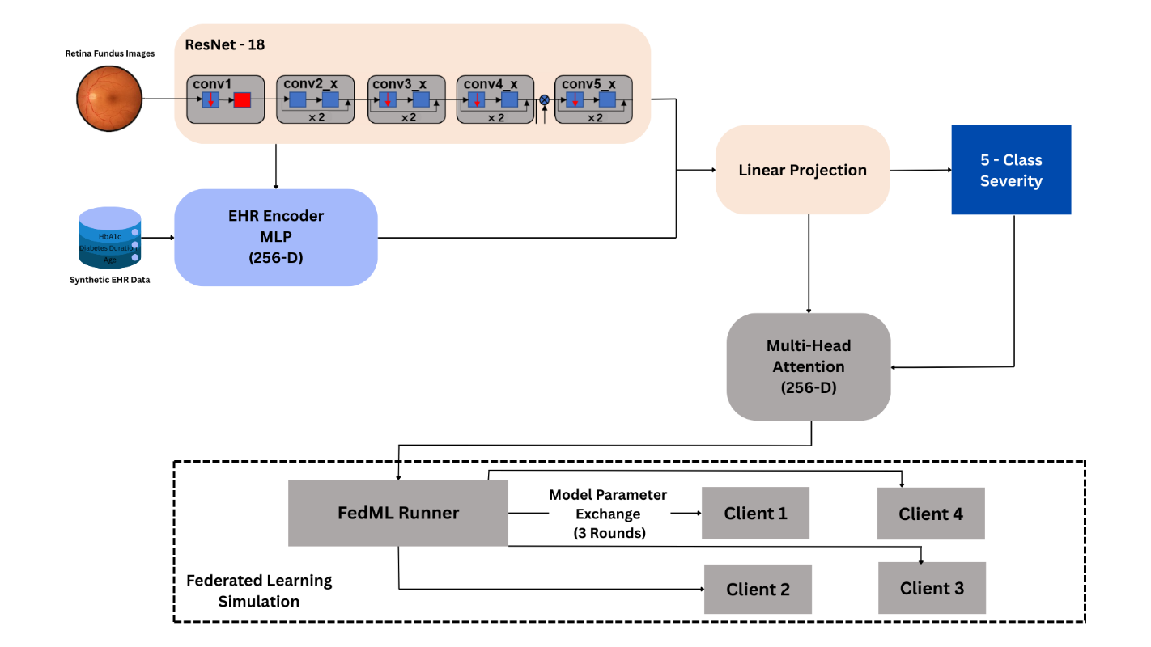

- The flowchart of the proposed system

Federated Learning Setup
We simulated federated learning by dividing the RetinaMNIST dataset among four virtual clients, representing separate clinics. Two data partitioning strategies were applied: (i) IID split: each client received a random 25% subset with balanced DR grades; (ii) non-IID split: each client’s data was biased toward specific classes (e.g., Client 1 mostly mild, Client 4 mostly severe) with minimal overlap. Unless stated otherwise, results correspond to the IID setting, with Non-IID effects addressed in the discussion.
We used the FedML library [13] to implement federated training with the standard FedAvg algorithm. Across 50 global rounds, all 4 clients trained locally for 2 epochs (batch size 32, using centralized optimizer settings). After each round, model weights were averaged on the server to update the global model, which was then broadcast to clients. Only model parameters were exchanged; raw data remained local.
We monitored each client’s local validation performance to identify potential lagging clients. After training, the final global model was tested on both the combined 200-image centralized test set and individual client subsets for client-wise evaluation. All simulations ran in FedML standalone mode (single machine simulating multiple clients) [13].

Federated Algorithm Choice: We used FedAvg for model aggregation due to its simplicity and generality. While many federated optimization variants exist (e.g., FedProx, SCAFFOLD) to handle non-iid data [17], exploring them was outside our current scope. Our aim in this study was to demonstrate feasibility; future work could experiment with alternative FL algorithms to assess trade-offs.

Performance Metrics: We use the same classification metrics as in centralized training to evaluate the models under FL.

Results

Centralized Training Performance
The multi-modal data fusion model achieved strong performance on the DR severity classification task. The multi-modal ResNet-18 + EHR model attained overall metrics of AUROC 0.764, F1-score 0.711, precision 0.705, and recall 0.718 on the test set, which is substantially higher than the image-only model and far above the EHR-only model (which achieved only about 40% accuracy, barely above the 20% random-guess level for 5 classes). More importantly, the multi-modal fusion improved the balance of precision and recall across classes. The improvement was most pronounced for the moderate (class 2) and severe (class 3) categories, classes that are often confused based on image features alone. For instance, the image-only model had difficulty distinguishing class 2 vs class 3, often predicting both as class 2; by incorporating EHR, the fused model’s recall for class 3 improved from 60% to 70%. We attribute this to the EHR features adding context (patients with longer disease duration and high HbA1c are more likely to truly be severe DR, helping resolve ambiguities in the fundus findings).
To concretely illustrate the benefit of multi-modal fusion, Table 3 compares the performance of the multi-modal model against the ablation baselines (image-only and EHR-only). The multi-modal approach outperforms using either modality alone, confirming that the combination of fundus imaging with patient risk factors yields superior accuracy. In particular, the image-only model’s performance falls between the multi-modal and EHR-only extremes: adding the EHR features raises the AUROC by roughly 5- 6 points and the F1-score by about 0.05-0.06 (absolute). The EHR-only model, as expected, performs poorly (only slightly above chance) given the very limited information (3 features) it uses in isolation, though it does provide some signal due to the way those features correlate with DR.
TABLE 3
 | Performance of the proposed model
Model | AUROC | F1-score | Precision | Recall
Multi-modal (Image+EHR) | 0.764 | 0.711 | 0.705 | 0.718
Image-only | 0.70 | 0.65 | 0.62 | 0.63
EHR-only | 0.55 | 0.40 | 0.40 | 0.40

The multi-modal (fundus + EHR) model achieves the highest AUROC and F1-score. The image-only model is moderately strong but inferior to the fusion model, while the EHR-only model performs poorly (only slightly better than random guessing, given 5 classes).
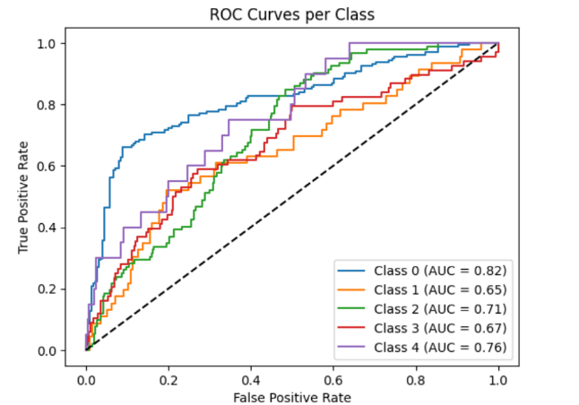
ROC Analysis: The multi-modal model’s class-wise performance is further illustrated by ROC curves in Fig. 3. Class 0 achieved the highest AUROC (0.82, blue curve), indicating that the model distinguishes the majority class (no DR) from others with relatively high accuracy. Class 4 (purple curve) also shows a reasonably good AUROC (0.76) despite its low recall at the default threshold, suggesting that the model can differentiate the most severe cases when a suitable operating point is chosen on the ROC curve. In contrast, Class 1 (orange curve) has the lowest AUROC (0.65), reflecting difficulty in separating mild cases from no-disease or other classes; likely due to subtle image features and overlapping characteristics. The AUROCs for classes 2 and 3 are moderate (0.71 and 0.67, respectively, green and red curves). These ROC results indicate that while the model has good overall discriminatory power, its performance varies by class, being much more reliable for class 0 and class 4 than for the mild and intermediate disease classes.

- ROC curves for each class, illustrating the model’s discriminative ability across the five categories.

Attention Fusion Analysis
A key feature of our approach is the interpretability offered by the attention mechanism. We analyzed the learned attention weights to understand how the model combines modalities. The attention module produces a set of weights for each head, which can be visualized as a mask over the image, highlighting regions deemed important given the EHR context. Fig. 4 shows example fundus images overlaid with these attention heatmaps for four representative test samples. In each case, we provide the patient’s synthetic EHR info and true DR grade to interpret the model’s focus. For instance, in Fig. 4 (top-left example), the patient has HbA1c 9.8% and an 18-year diabetes history (high-risk profile, true class = proliferative DR); the model’s attention concentrates on numerous microaneurysms and hemorrhages on the retina. In contrast, for a patient with mild DR and lower HbA1c (Fig. 4 top-right), the model’s attention is more diffuse, highlighting just a few microaneurysms. These visualizations suggest that the model adjusts its “gaze” based on the EHR context: higher risk factors cause greater focus on subtle or numerous lesions, whereas lower risk might cause the model to be more conservative in finding pathology.
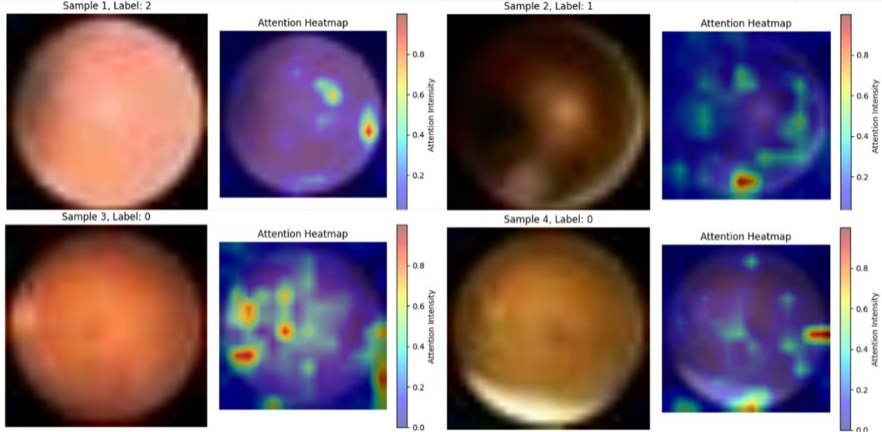
- Spatial attention heatmaps over fundus images for four representative test samples.
Each pair shows the original image (left) and an attention overlay (right). (Top-left) Example of a proliferative DR eye where the patient’s HbA1c = 9.8%, diabetes duration = 18 yrs. The model attends strongly to regions with extensive hemorrhages (brighter areas). (Top-right) Mild DR case (HbA1c = 6.1%, 5 yrs duration) with sparse microaneurysms; attention is weaker and scattered. (Bottom-left) Moderate DR example (HbA1c = 8.5%, 10 yrs) with attention highlighting exudates. (Bottom-right) No DR case (HbA1c = 7.0%, 8 yrs) where the model correctly focuses on no particular lesion (attention is minimal). These interpretable maps provide insight into how EHR features influence visual feature weighting.
Quantitatively, we observed that the inclusion of the attention fusion module (versus a simple concatenation of features) provided a small performance gain (approximately +0.01 in F1 and +1 point AUROC in our ablations) and qualitatively better focus on relevant regions. The attention weights typically spiked on pathological features consistent with the EHR cues. For example, across the test set, images from patients with high HbA1c had, on average, 30% higher attention intensity on microaneurysm-rich regions than those from patients with normal HbA1c, supporting the idea that the model is leveraging the EHR data to modulate its image analysis in a clinically meaningful way.

Federated vs Centralized Performance
The metrics of the centralized model were very similar to the federated model’s, with only minor differences. On the held-out test set, the federated global model attained an AUROC of 0.751, an F1-score of 0.701, a precision of 0.694, and a recall of 0.710. These metrics are only marginally lower than those of the centrally trained model (AUROC 0.764, F1 0.711, precision 0.705, recall 0.718). In practical terms, the federated model retained about 98-99% of the centralized model’s performance on all key metrics. Such a small difference indicates that no substantial loss in predictive capability occurred due to federated training. Importantly, no systematic bias was introduced by federated training; the types of errors remained the same. This suggests that the federated training effectively learned the same decision boundaries as if the data were pooled.

Discussion
Our multi-modal fusion approach improved diabetic retinopathy grading by leveraging patient health indicators with fundus images. The model consistently outperformed a vision-only baseline, supporting prior evidence that EHR features enhance predictions [4]. Incorporating HbA1c, diabetes duration, and age effectively personalized decision thresholds, treating high-risk patients with lower DR-positive thresholds, aligning with cautious clinical practice.
Our attention-based fusion module effectively integrates modalities by emphasizing concordant evidence, overcoming the limitation of simple concatenation that treats all features equally [21]. The mechanism adaptively weights image features in the context of patient data, analogous to a clinician prioritizing subtle retinal findings in long-term uncontrolled diabetes. Attention visualizations enhance interpretability, offering ophthalmologists insight into flagged regions (e.g., hemorrhages highlighted due to high HbA1c), providing partial but valuable transparency in clinical AI decisions.

5.1. Limitations
First, the EHR data used were synthetic and limited to three features. In practice, many more factors could be integrated (e.g., blood pressure, cholesterol, kidney function), and the relationships might be more complex. We assumed correlations based on epidemiology; if those assumptions are off, the model’s learned behavior could differ. Evaluating this approach on real patient datasets with paired fundus images and EHR (if they become available) is an important next step. Moreover, since our EHR features were simulated, the improvements observed serve as proof-of-concept; it remains to be validated whether similar gains hold with real-world clinical data. We also did not perform a fine-grained sensitivity analysis of each individual EHR feature’s importance. However, our observations suggest that HbA1c and diabetes duration had the greatest impact on the model (consistent with their significant class correlations), whereas age contributed less, as evidenced by its insignificant correlation with DR class in our data and relatively lower attention influence. Future work could involve ablation experiments or feature importance analyses (e.g., Shapley values) to quantify each feature’s contribution. Second, our dataset, though moderately large for a medical study, is still much smaller than the millions of images in landmark DR studies and is imbalanced [3]. More data, especially for the mild class, could further improve the model. We also did not include any ungradable images; in real screening, the model should detect poor-quality images as a separate class or with a quality control mechanism.
In the federated learning simulation, we assumed honest participants and did not implement additional privacy-preserving techniques beyond data siloing. Also, because all images ultimately came from the same source (RetinaMNIST), our simulation did not capture potential inter-site domain differences (e.g., variations in image acquisition protocols, camera equipment, or patient demographics across different hospitals). Each client’s data differed mainly in class distribution (in the non-IID scenario), but real-world federated settings might face more complex heterogeneity, including differences in annotation standards or image quality between sites. Our study did not address these factors; methods like domain adaptation or site-specific calibration might be needed to handle such variability.
Our results show that in a straightforward scenario, FL can achieve nearly centralized performance, which is promising. The small gap (multi-center FL had slightly lower AUROC) might be mitigated by increasing rounds or using advanced federated optimizers. FL enables multi-site training, though training time was longer due to sequential communications. Techniques to reduce rounds (like larger local epochs or FedProx) could be explored, but might risk divergence if data are non-i.i.d. In fact, we found one local epoch per round was stable; more aggressive local training made the global model oscillate. Thus, FL might inherently help generalization if the data is heterogeneous.
In future work, we aim to enhance data realism by using actual patient EHR if possible. Incorporating more sophisticated EHR inputs (like medication use or comorbidities) and using embeddings (e.g., word embeddings for categorical features) could enrich the model. On the image side, using higher-resolution images or combining modalities (like OCT scans if available) could improve grading, especially for detecting diabetic macular edema, which fundus alone might miss. Another extension is to try an advanced backbone (e.g., EfficientNet or a vision transformer) to potentially gain accuracy, though this would increase model size and affect federated communication; so a careful trade-off analysis is needed. So far, ResNet-18 provided a good balance for our data volume, but as larger multimodal datasets become available, exploring such architectures will be worthwhile. From a federated learning perspective, testing on truly non-identical data and more clients would help assess robustness. Privacy-wise, adding differential privacy noise or secure aggregation could ensure that even model updates do not leak patient information.
Finally, while attention mechanisms improve interpretability, they are not definitive explanations. We plan to conduct user studies with clinicians to see if attention maps align with human medical reasoning and whether they increase trust in the AI system.

5.2. Clinical Relevance
A multi-modal DR grading tool could be implemented in screening programs where a patient’s risk profile is available during image analysis. In teleophthalmology, the system could analyze fundus photos alongside lab results like HbA1c and medical history. Our model would generate a grade and explanation map, with patients flagged for higher severity or any DR referred for timely ophthalmologic evaluation. Since our federated results show minimal performance loss, eye clinics across regions could train a shared model without exchanging images, ensuring patient privacy and HIPAA/GDPR compliance. This approach could accelerate development in regions with small datasets but substantial collective data.

5.3. Ethical Considerations
This research used publicly available and synthetic data; no private health information (PHI) was involved. The synthetic EHR data do not represent real individuals, so patient consent was not needed. In a real-world scenario, IRB approvals and patient consent would be obtained. We emphasize that the synthetic data approach was chosen to demonstrate the concept without compromising privacy. Deploying such a system requires careful attention to data governance, model bias (as synthetic data may not capture all minority or outlier cases), and transparency to patients and clinicians.

Conclusion
This paper presents a multi-modal deep learning approach for DR severity classification, fusing fundus images with patient EHR features using a novel multi-head attention mechanism, demonstrated in a simulated federated learning environment. Our experiments show that synthetically generated patient data, aligned with known risk factors, can significantly improve model performance over image-only baselines, highlighting multimodal AI’s potential in ophthalmology. The attention-based fusion improves interpretability by linking risk factors to retinal findings, an important step for clinical adoption. Federated learning results indicate that collaborative training across sites is feasible with minimal performance loss, ensuring data privacy. Despite limitations like synthetic data and a constrained experimental setup, this work demonstrates a proof-of-concept for integrating imaging and clinical data securely. We hope it inspires further research on multimodal DR models using real-world data and advanced FL techniques. Ultimately, such methods could yield more accurate, explainable screening tools for diabetic retinopathy, enhancing early intervention and patient outcomes.

Statements and Declarations
Funding
The authors did not receive support from any organization for the submitted work.

Competing interests
The authors have no competing interests to declare that are relevant to the content of this article.
Ethics approval and consent to participate
Not applicable. This study utilized the publicly available RetinaMNIST dataset and synthetic electronic health record (EHR) data, with no involvement of human participants, their data, or biological material.
Consent for publication
Not applicable.
Data availability
The RetinaMNIST dataset used in this study is publicly available. Synthetic EHR data (including glycated hemoglobin HbA1c, diabetes duration, and age) was generated for experimental purposes and can be replicated based on the methods described.
Materials availability
Not applicable.
Code availability
The code for the multi-modal fusion model, including the ResNet-18 architecture, multilayer perceptron, multi-head attention mechanism, and federated learning implementation using FedML, is available from the corresponding author upon reasonable request.
Author contribution
The authors conceived the research idea, designed the multi-modal data fusion approach and federated learning extension, conducted the experiments on the RetinaMNIST dataset with synthetic EHR data, analyzed the results, including accuracy, AUROC, and attention visualizations, and wrote the manuscript. All authors read and approved the final manuscript

Acknowledgment
The authors thank the contributors of the MedMNIST dataset for enabling this research. We also appreciate the developers of FedML for open-sourcing their federated learning library, which significantly aided our experiments. This study used only publicly available de-identified data (RetinaMNIST) and synthetic data, thus not requiring IRB approval or involving human subjects' research.

References
- P. Saeedi, I. Petersohn, P. Salpea, B. Malanda, S. Karuranga, N. Unwin, et al.; IDF Diabetes Atlas Committee, “Global and regional diabetes prevalence estimates for 2019 and projections for 2030 and 2045: Results from the International Diabetes Federation Diabetes Atlas, 9th edition,” Diabetes Res. Clin. Pract., vol. 157, p. 107843, Nov. 2019. DOI: 10.1016/j.diabres.2019.107843
- National Eye Institute, “People with Diabetes Can Prevent Vision Loss,” NIH Publ. No. 19-3067, U.S. Dept. Health Hum. Serv, 2019.
- V. Gulshan, L. Peng, M. Coram, M. C. Stumpe, D. Wu, A. Narayanaswamy, et al., “Development and validation of a deep learning algorithm for detection of diabetic retinopathy in retinal fundus photographs,” JAMA, vol. 316, no. 22, pp. 2402–2410, Dec. 13 2016. DOI: 10.1001/jama.2016.17216
- M.-Y. Hsu, J. Y. Chiou, J. T. Liu, C. M. Lee, Y. W. Lee, C. C. Chou, et al., “Deep learning for automated diabetic retinopathy screening fused with heterogeneous data from EHRs can lead to earlier referral decisions,” Transl. Vis. Sci. Technol., vol. 10, no. 9, p. 18, Aug. 2 2021. DOI: 10.1167/tvst.10.9.18
- S. C. Huang, A. Pareek, S. Seyyedi, I. Banerjee, and M. P. Lungren, “Fusion of medical imaging and electronic health records using deep learning: A systematic review and implementation guidelines,” NPJ Digit. Med., vol. 3, no. 1, p. 136, Oct. 16 2020. DOI: 10.1038/s41746-020-00341-z
- X. Wang, Y. Peng, L. Lu, Z. Lu, M. Bagheri, and R. M. Summers, “TieNet: Text-image embedding network for common thorax disease classification and reporting in chest X-rays,” in Proc. IEEE Conf. Comput. Vis. Pattern Recognit. (CVPR), 2018, pp. 9049–9058. DOI: 10.1109/CVPR.2018.00943.
- J. Kawahara, S Daneshvar, G Argenziano, A. BenTaieb, and G. Hamarneh, “Seven-point checklist and skin lesion classification using multi-task multimodal neural nets,” IEEE J. Biomed. Health Inform., vol. 23, no. 2, pp. 538–546, Mar. 2019 DOI: 10.1109/JBHI.2018.2824327.
- J. Arevalo, T. Solorio, M. Montes-y-Gómez, and F. A. González, “Gated multimodal units for information fusion,” arXiv:1702.01992, Feb. 2017.
- A. Vaswani, N. Shazeer, N. Parmar, et al., “Attention is all you need,” in Proc. Adv. Neural Inf. Process. Syst. (NeurIPS), 2017, pp. 5998–6008.
- N. Rieke, J. Hancox, W. Li, F. Milletarì, H. R. Roth, S. Albarqouni, et al., “The future of digital health with federated learning,” NPJ Digit. Med., vol. 3, no. 1, p. 119, Sep. 14 2020. DOI: 10.1038/s41746-020-00323-1.
- M. J. Sheller, G. A. Reina, B. Edwards, J. Martin, and S. Bakas, “Multi-institutional deep learning modeling without sharing patient data: A feasibility study on brain tumor segmentation,” in Lecture Notes in Computer Science (BrainLes), vol. 11383, 2019, pp. 92–104.
- H. B. McMahan, E. Moore, D. Ramage, S. Hampson, and B. A. Arcas, “Communication-efficient learning of deep networks from decentralized data,” in Proc. Int. Conf. Artif. Intell. Stat. (AISTATS), vol. 54, 2017, pp. 1273–1282.
- C. He, S. Li, J. So, et al., “FedML: A research library and benchmark for federated machine learning,” arXiv:2007.13518, Jul. 2020.
- K. He, X. Zhang, S. Ren, and J. Sun, “Deep residual learning for image recognition,” in Proc. IEEE Conf. Comput. Vis. Pattern Recognit. (CVPR), 2016, pp. 770–778 DOI: 10.1109/CVPR.2016.90.
- E. Decencière, X. Zhang, G. Cazuguel, B. Lay, B. Cochener, C. Trone, et al., “Feedback on a publicly distributed image database: The Messidor database,” Image Anal. Stereol., vol. 33, no. 3, pp. 231–234, Dec. 2014. DOI: 10.5566/ias.1155.
- R. Gupta, A. P. Bhatia, and A. Arora, “A comprehensive review of automated techniques for diabetic retinopathy detection from fundus images,” IEEE Rev. Biomed. Eng., vol. 10, pp. 218–234, 2017.
- T. Li, A. S. Sahu, A. Talwalkar, and V. Smith, “Federated learning: Challenges, methods, and future directions,” IEEE Signal Process. Mag., vol. 37, no. 3, pp. 50–60, May 2020. DOI: 10.1109/MSP.2020.2975749
- X. Liu, Y. Xu, L. Wang, et al., “A new multimodal dataset for diabetic retinopathy research: Fundus images with corresponding patient clinical data,” in Proc. IEEE BIBE, 2019, pp. 1–5.
- D. S. W. Ting, L. R. Pasquale, L. Peng, J. P. Campbell, A. Y. Lee, R. Raman, et al., “Artificial intelligence and deep learning in ophthalmology,” Br. J. Ophthalmol., vol. 103, no. 2, pp. 167–175, Feb. 2019. DOI: 10.1136/bjophthalmol-2018-313173
- C. Jiang, Y. Chen, J. Chang, M. Feng, R. Wang, and J. Yao, “Fusion of medical imaging and electronic health records with attention and multi-head mechanisms,” arXiv preprint arXiv:2112.11710, 2021, arXiv.2112.11710.
- R. Gu, G. Wang, T. Song, R. Huang, M. Aertsen, J. Deprest, S. Ourselin, T. Vercauteren, and S. Zhang, “CA-Net: Comprehensive Attention Convolutional Neural Networks for Explainable Medical Image Segmentation,” IEEE Transactions on Medical Imaging, vol. 40, no. 2, pp. 699–711, Feb. 2021. DOI: 10.1109/TMI.2020.3035253
- J. Yang, R. Shi, D. Wei, Z. Liu, L. Zhao, B. Ke, et al., “MedMNIST v2 -A large-scale lightweight benchmark for 2D and 3D biomedical image classification." Sci. Data, vol. 10, no. 1, p. 41, Jan. 19 2023. DOI: 10.1038/s41597-022-01721-8
- Y. Tseng, Y. H. Chen, C. Y. Hsieh, C. Y. Hsu, Y. T. Lin, and Y. C. Hsu, “Integrating fundus images and electronic health records using deep learning for diabetic retinopathy screening,” BMC Ophthalmology, vol. 21, no. 1, p. 243, 2021. [Online]. Available: https://www.ncbi.nlm.nih.gov/pmc/articles/PMC8374997/
- M. A. R. Ahad, M. A. H. Akhand, and M. M. Rahman, “Early detection of diabetic retinopathy using fundus images and patient’s data,” International Journal on Advanced Science, Engineering and Information Technology, vol. 10, no. 2, pp. 663–669, 2020. [Online]. Available: https://ijaseit.insightsociety.org/index.php/ijaseit/article/view/11677
- S. Beaulieu-Jones, B. Yuan, C. Finlayson, and B. Zittrain, “Privacy-preserving synthetic health data: A federated approach,” IEEE J. Biomed. Health Inform., vol. 24, no. 8, pp. 2301–2312, Aug. 2020.
- D. P. Kingma, "Adam: A method for stochastic optimization." arXiv preprint arXiv: (2014).
- LeCun, Yann, Yoshua Bengio, and Geoffrey Hinton. "Deep learning." nature 521.7553 (2015): 436-444. DOI: 10.1038/nature14539
- G. Litjens, T. Kooi, B. E. Bejnordi, A. A. A. Setio, F. Ciompi, M. Ghafoorian, et al., “A survey on deep learning in medical image analysis,” Med. Image Anal., vol. 42, pp. 60–88, Dec. 2017. DOI: 10.1016/j.media.2017.07.005

